MEDBUDDY: AI-Powered Medical Chatbot with Retrieval-Augmented Generation
Mini Project Report

Submitted by
ADITHYA BAIJU RIE23CS006
AKHIL KUNDUVALAPPIL RIE23CS011
DEVIKA RIE23CS019
PAVITHRA P S RIE23CS037
PRAKHAR SHARMA RIE23CS039

to
APJ Abdul Kalam Technological University
in partial fulfillment of the requirements for the award of the Degree of
Bachelor of Technology (B.Tech) in
Computer Science and Engineering
Under the guidance of
Ms. Amrutha S Aravind



Department of Computer Science and Engineering Rajadhani Institute of Engineering and TechnologyNagaroor, Thiruvananthapuram
March 2026

DECLARATION
I undersigned hereby declare that the mini project report "MEDBUDDY: AI-Powered Medical Chatbot with Retrieval-Augmented Generation Mini Project Report", submitted for partial fulfillment of the requirements for the award of degree of Bachelor of Technology of the APJ Abdul Kalam Technological University, Kerala is a bonafide work done by us under the supervision of Ms. Amrutha S Aravind, Assistant Professor, Department of Computer Science & Engineering.
This submission represents our ideas in our own words and where ideas or words of others have been included. We have adequately and accurately cited and referenced the original sources. We also declare that we have adhered to ethics of academic honesty and integrity and have not misrepresented or fabricated any data or idea or fact or source in our submission. We understand that any violation of the above will be a cause for disciplinary action by the institute and/or the University and can also evoke penal action from the sources which have thus not been previously formed the basis for the award of any degree, diploma or similar title of any other University.

Place: NAGAROOR Signature
Date: March, 2026 PAVITHRA P S (RIE23CS037)

DEPARTMENT OF COMPUTER SCIENCE AND ENGINEERING


CERTIFICATE
This is to certify that the report entitled 'MEDBUDDY: AI-Powered Medical Chatbot with Retrieval-Augmented Generation Mini Project Report' submitted by PRAKHAR SHARMA (RIE23CS039), AdithyaBaiju (RIE23CS006), Akhil Kunduvalappil (RIE23CS011), DEVIKA (RIE23CS019), and PAVITHRA P S (RIE23CS037) to the APJ Abdul Kalam Technological University for the partial fulfillment of the requirements for the award of the Degree of Bachelor of Technology in Computer Science and Engineering is a bonafide record of the project work carried out by them under our guidance and supervision. This report in any form has not been submitted to any other University or Institute for any purpose.

Dr. SANGEETHA SHIBU
Head of the Department(HoD)

Ms. AMRUTHE S ARAVIND Ms. AHTIRA SARATH
Assistant Professor Project Guide Assistant professor, Programe

ACKNOWLEDGEMENT

First and foremost, we express our heartfelt thanks and profound gratitude to the Management of Rajadhani Institute of Engineering and Technology and our Principal, Dr. MADHUKUMAR S for providing all the facilities to carry out this mini project work.
We are extremely happy to mention a great word of gratitude to Dr. SANGEETHA SHIBU, Head of department of computer science and engineering, for her valuable suggestions and encouragement to carry out this mini project work.
We would like to express our sincere gratitude to our guide Ms. Amrutha S Aravind, for her relevant suggestions, guidance and inestimable leadership given for the completion of this mini project work.
We thank our Mini Project Coordinator Ms. Athira Sarath for her constant encouragement during the entire mini project work.
Finally, we take this opportunity to express our gratitude to our parents for their love, care and support and also to our friends and well-wishers who have been constant sources of support and inspiration for completing the mini project work.

VISION OF THE INSTITUTE
Groom the Youth as Innovative, Creative and Empathetic Technologists, Hospitality Professionals, Managers and Entrepreneurs for Social Transformation.

MISSION OF THE INSTITUTE
- M1: To encourage holistic development of students with well-balanced curricular, co-curricular and extra-curricular activities.
- M2: To promote ethical and value-oriented teaching, research and consultancy among faculty and students for social transformation.
- M3: To interact with industrial organizations, governmental agencies, engineering, hospitality and business enterprises for collaborative learning.

VISION OF THE DEPARTMENT
Mould competent professionals in the field of Computer Science & Engineering.

MISSION OF THE DEPARTMENT
- M1: To develop competency in Computer Science & Engineering through outcome-based education.
- M2: To enhance research and innovations in advanced computing technology.
- M3: To inculcate social skills and entrepreneurship through collaborative learning.

PROGRAMME EDUCATIONAL OBJECTIVES (PEOs)
Graduates will:
- PEO 1: Exhibit knowledge and proficiency in various domains of Computer Science & Engineering.
- PEO 2: Develop innovative computing products for reconcile contemporary issues in industry.
- PEO 3: Demonstrate team work, ethical leadership and promote entrepreneurship.

PROGRAMME SPECIFIC OUTCOMES (PSOs)
Graduates are able to:
- PSO 1: Analyse and design solutions for complex problems in computing technologies using software project management concepts and programming languages.
- PSO 2: Develop proficiency in inter-disciplinary areas of computer engineering to perform tasks related to industry & research.
- PSO 3: Solve real world problems pertaining to product and services in Information Technology.

PROGRAMME OUTCOMES (POs)
- Engineering knowledge: Apply the knowledge of mathematics, science, engineering fundamentals, and an engineering specialization to the solution of complex engineering problems.
- Problem analysis: Identify, formulate, review research literature, and analyse complex engineering problems reaching substantiated conclusions using first principles of mathematics, natural sciences, and engineering sciences.
- Design/development of solutions: Design solutions for complex engineering problems and design system components or processes that meet the specified needs with appropriate consideration for the public health and safety, and the cultural, societal, and environmental considerations.
- Conduct investigations of complex problems: Use research-based knowledge and research methods including design of experiments, analysis and interpretation of data, and synthesis of the information to provide valid conclusions.
- Modern tool usage: Create, select, and apply appropriate techniques, resources, and modern engineering and IT tools including prediction and modelling to complex engineering activities with an understanding of the limitations.
- The engineer and society: Apply reasoning informed by the contextual knowledge to assess societal, health, safety, legal and cultural issues and the consequent responsibilities relevant to the professional engineering practice.
- Environment and sustainability: Understand the impact of the professional engineering solutions in societal and environmental contexts, and demonstrate the knowledge of, and need for sustainable development.
- Ethics: Apply ethical principles and commit to professional ethics and responsibilities and norms of the engineering practice.
- Individual and team work: Function effectively as an individual, and as a member or leader in diverse teams, and in multidisciplinary settings.
- Communication: Communicate effectively on complex engineering activities with the engineering community and with society at large, such as, being able to comprehend and write effective reports and design documentation, make effective presentations, and give and receive clear instructions.
- Project management and finance: Demonstrate knowledge and understanding of the engineering and management principles and apply these to one's own work, as a member and leader in a team, to manage projects and in multidisciplinary environments.
- Life-long learning: Recognize the need for, and have the preparation and ability to engage in independent and life-long learning in the broadest context of technological change.

Course Outcomes (COs)
After successful completion of the course the students will be able to:
- CO1: Identify technically and economically feasible problems (Cognitive Knowledge Level: Apply).
- CO2: Identify and survey the relevant literature for getting exposed to related solutions and get familiarized with software development processes (Cognitive Knowledge Level: Apply).
- CO3: Perform requirement analysis, identify design methodologies and develop adaptable & reusable solutions of minimal complexity by using modern tools & advanced programming techniques (Cognitive Knowledge Level: Apply).
- CO4: Prepare technical report and deliver presentation (Cognitive Knowledge Level: Apply).
- CO5: Apply engineering and management principles to achieve the goal of the project (Cognitive Knowledge Level: Apply).

CO-PO Mapping
 | PO1 | PO2 | PO3 | PO4 | PO5 | PO6 | PO7 | PO8 | PO9 | PO10 | PO11 | PO12
CO1 | 3 | 3 | 3 | 3 | 3 | 2 | 2 | 2 | 2 | 2 | 2 | 2
CO2 | 3 | 3 | 3 | 3 | 3 | 3 | - | 2 | 2 | 2 | 2 | 2
CO3 | 3 | 3 | 3 | 3 | 3 | 2 | 2 | 2 | 2 | 2 | 2 | 2
CO4 | 3 | 3 | 3 | 3 | 3 | - | - | 2 | 2 | 2 | 2 | 2
CO5 | 3 | 3 | 3 | 3 | 3 | 2 | 2 | 2 | 2 | - | 2 | 2

ABSTRACT

Generic AI hallucinations present a critical risk in medical education, as standard models often lack transparency regarding their sources and are prone to providing false syllabus information. To address this, Med-Buddy is presented as an intelligent Retrieval-Augmented Generation (RAG) framework designed to create a secure, hallucination-free study environment by mathematically matching user queries to verified textbook paragraphs. While the base implementation utilized the Google Gemini API within the LlamaIndex framework, it faced significant operational hurdles due to restrictive rate limits and high costs; therefore, our primary contribution involves transitioning the architecture to the Grok LLM to effectively eliminate API exhaustion issues while integrating TruLens for advanced RAG evaluation—utilizing "RAG Triad" metrics (context relevance, groundedness, and answer relevance) to provide real-time quality scores. Furthermore, the framework was enhanced by integrating Local FastEmbed for on-device vectorization and a persistent indexing mechanism using MD5 hashing to allow interrupted document processing to resume seamlessly, all deployed via a Streamlit-based user interface that offers a responsive, web-based dashboard for seamless interaction with verified medical literature. By combining the high-speed Grok engine with optimized local data parsing and rigorous metric-based validation, Med-Buddy offers a scalable, cost-effective solution that transforms unstructured medical literature into actionable, verified insights for students.

CONTENTS
Chapter / Section | Topic Description | Page No.
Chapter 1 | INTRODUCTION
1.1 | Overview | 11
1.2 | List of Libraries | 12
Chapter 2 | LITERATURE SURVEY | 13
2.1 | A Survey on Medical RAG Architectures | 14
2.2 | Base Paper Implementation: Gemini-based Clinical Retrieval
2.3 | Integration of Hugging Face Transformers for Local Processing
2.4 | Comparative Study of Proprietary vs Open-Source LLMs
Chapter 3 | EXISTING SYSTEM | 14
3.1 | Base Paper System (Gemini API Dependent)
3.2 | Disadvantages of Existing System
Chapter 4 | PROPOSED SYSTEM | 15
4.1 | Proposed MedBuddy Hybrid Framework
4.2 | Contribution: Hugging Face Local Embedding Integration | 16
Chapter 5 | SYSTEM REQUIREMENTS
5.1 | Hardware Specifications
5.2 | Software Specifications (Python, Hugging Face, Gemini SDK)
Chapter 6 | DESIGN & IMPLEMENTATION | 17
6.1 | Base paper implementaion
6.2 | System Architecture | 18
6.3 | OUR CONTRIBUTION | 19
6.4 | FLOW CHART | 21
6.5 | IMPLEMENTATION | 23
Chapter 7 | RESULT | 37
7.1 | Home Page | 37
7.2 | Query Interface & Result Generation | 38
7.3 | Performance Comparison (Base vs. Contributed) | 40
Chapter 8 | CONCLUSION AND FUTURE SCOPE | 43
8.1 | Conclusion | 43
8.2 | Future Scope | 43
 | REFERENCES | 44

LIST OF FIGURES

LIST OF TABLES
LIST OF ABREVATIONS
CHAPTER 1

1.INTRODUCTION

1.1 Overview
The evolution of AI in education has introduced significant potential for improving learning environments, particularly in demanding fields such as medicine. However, generic AI hallucinations present a critical risk; normal LLMs are not transparent about their sources and are highly prone to fabrication without a dedicated retrieval system. Med-Buddy is a digital assistant designed to serve as a friendly and accurate resource, responding promptly to complex medical queries to optimize study time.
The platform features a frictionless interface for secure medical document upload, supporting dense PDFs up to 200MB. Once a document is uploaded, the Gemini engine is locked strictly to that context, bypassing generic web data to fetch only mathematically matched textbook chunks.

1.2 Motivation
The motivation behind Med-Buddy stems from the necessity to provide tangible assistance to medical students facing the stress of massive curricula. Existing systems often lack professional verification and reliable source-tracking, leading to authenticity issues. There is a clear need for a system that isolates medical knowledge from generative AI creativity to ensure guaranteed safety.
To achieve this, the project is motivated by three technical pillars:
- Embeddings: Turning human sentences into mathematical number-lists so the computer understands exact medical context.
- Vector Database: A specialized storage space for "number-words" allowing instant matching of user questions to verified textbook paragraphs.
- LLM Grounding: A strict software rule forcing the AI to only generate answers using the uploaded text, completely stopping outside fabrication.
Ultimately, Med-Buddy aims to democratize safe access to complex medical knowledge, allowing students to study smarter and interview better by fundamentally shifting focus from data retrieval to true medical comprehension.

1.2 LIST OF LIBRARIES
Library | Purpose
Streamlit | Powers the entire web-based interface, including the chat environment and session management.
LlamaIndex | Acts as the core data framework for document ingestion, text chunking (node parsing), and vector indexing.
Google Generative AI | Provides the Gemini LLM and embedding models used in the base implementation for medical queries.
Grok | Serves as a high-performance LLM provider to overcome the rate limits and API exhaustion found in the Gemini free tier.
TruLens | Performs real-time evaluation of AI groundedness and answer relevance to ensure a hallucination-free experience.
FastEmbed | Provides local, efficient text embeddings, allowing the system to process data without relying on external cloud APIs.
PyMuPDFReader | A specialized PDF parser used to accurately extract text and layout information from dense medical textbooks.
BeautifulSoup4 | Functions as a fallback structural parser to ensure data is correctly extracted if the primary reader fails.
LiteLLM | Operates as a universal adapter to connect the TruLens evaluation tools with the Groq engine.
NumPy | Manages the mathematical representation of data and handles complex numerical operations for vector arrays.
Hashlib | Generates MD5 and SHA-256 hashes for verifying file integrity and managing the persistent index cache.
OS / Tempfile | Handles system-level tasks such as managing environment variables, file paths, and temporary document storage.
Asyncio / Time | Manages non-blocking execution for API calls and handles necessary delays to prevent request throttling.
JSON | Stores and loads system checkpoints and configuration data to allow for resume-able indexing.

CHAPTER 2

2.LITERATURE SURVEY

2.1 AI Chatbots in Medical Education and Public Health
Recent studies (Baglivo et al., 2023; Eysenbach, 2023) explore the transformative role of AI chatbots in medical education and public health. Research demonstrates that AI tools effectively support vaccination training, enhance learning outcomes, and accelerate medical research cycles. The emphasis remains on responsible AI integration with rigorous accuracy validation. These works highlight how Large Language Models are fundamentally transforming knowledge delivery in healthcare contexts.

2.2 Retrieval-Augmented Generation (RAG) in Medical Chatbots
Retrieval-Augmented Generation represents a paradigm shift in how medical information systems operate. Unlike standalone LLMs, RAG systems (Bhavani Peri et al., 2024; Zhou et al., 2024) combine retrieval mechanisms with generative capabilities to ensure responses are grounded in authoritative medical sources. The GastroBot system demonstrates RAG's effectiveness for domain-specific medical chatbots, achieving high accuracy through integration with verified knowledge bases. These systems dynamically retrieve relevant information before generation, ensuring that every response references validated medical literature. RAG effectively eliminates hallucinations by constraining the generation space to retrieved, verified content.

2.3 Embedding Models and Semantic Search
The performance of RAG systems is fundamentally dependent on embedding quality. Recent research (Wang et al., 2024; Chen et al., 2024) evaluates multilingual embedding models including E5, BGE M3, and OpenAI embeddings. These models employ self-knowledge distillation and multi-functionality approaches to achieve state-of-the-art semantic search performance. The choice of embedding model directly impacts retrieval precision and, consequently, the quality of generated responses. Multi-lingual embeddings like BGE M3 provide robustness across diverse textbooks and research sources.

2.4 Large Language Models in Healthcare
The application of LLMs like GPT, Claude, and Google Gemini in healthcare raises both opportunities and challenges. Studies demonstrate that while LLMs excel at pattern recognition and knowledge synthesis, they require external grounding mechanisms to ensure medical accuracy. Integration with verified knowledge bases, continuous fine-tuning on domain-specific data, and systematic evaluation frameworks are essential for responsible medical AI deployment.

CHAPTER 3

3.EXISTING SYSTEM
3.1 Existing System (Base Paper Architecture)
The existing system, as outlined in our base implementation and initial studies, operates as a purely cloud-dependent Retrieval-Augmented Generation (RAG) application. In this monolithic architecture, absolutely every stage of the NLP pipeline relies on the external Gemini API ecosystem.
The workflow of the existing system operates as follows: When medical PDFs or clinical documents are uploaded by the user, the application extracts the raw text and immediately formats it into JSON payloads. These payloads are transmitted over the internet to the Gemini Embedding endpoint. Google's servers process the text, generate the dense vector embeddings, and send them back to the application to be stored in a local vector database.
During the retrieval phase, the application experiences further cloud dependency. The user's medical query is sent to the Gemini API to be vectorized. Once the local database performs a similarity search and retrieves the matching document chunks, these chunks, alongside the user's original query, are bundled into a final prompt and sent again to the Gemini Pro generative model. The model processes the massive context window on Google's servers and returns the final conversational output.
3.2 Disadvantages of Existing System
While functionally capable, the existing cloud-only system suffers from several critical disadvantages that preclude its use in professional healthcare environments:
- Severe Data Privacy and Compliance Risks: Uploading proprietary medical documents, sensitive patient data, or internal hospital protocols to external, third-party servers is a massive security vulnerability. This architecture inherently violates strict medical data privacy laws and ethical guidelines regarding patient confidentiality.
- Exorbitant API Costs: Generating embeddings for large volumes of data (such as thousands of pages of medical textbooks or years of clinical trial data) consumes millions of tokens. In a purely cloud-based system, every single word indexed incurs a financial cost, leading to rapidly escalating, unsustainable operational expenses.
- High Latency and Network Dependency: The system is entirely bottlenecked by internet bandwidth and the response times of the cloud provider. Uploading large documents for cloud vectorization is painfully slow.
- Rate Limiting: Cloud providers impose strict rate limits (Requests Per Minute/Tokens Per Minute). Attempting to ingest a large medical corpus often results in API crashes and timeouts, making the system fragile and unreliable for bulk data processing.
CHAPTER 4

4.PROPOSED SYSTEM

4.1 Proposed System (MedBuddy Hybrid Framework)
The proposed system, MedBuddy, introduces a sophisticated, hybrid RAG framework that fundamentally restructures the processing pipeline to maximize both security and artificial intelligence capabilities. Recognizing the fatal flaws of the existing system, MedBuddy bifurcates the workload.
Instead of transmitting raw medical documents to the cloud for indexing, the MedBuddy system processes, cleans, chunks, and vectorizes all medical data locally on the host machine. The vector database (utilizing highly optimized libraries such as FAISS or ChromaDB) resides entirely on the local file system. The cloud-based LLM (Gemini) is explicitly restricted from the data ingestion phase and is only invoked at the very end of the pipeline. When a user asks a question, the local system retrieves only the most highly relevant, isolated paragraphs. Only this strictly filtered, minimized context is sent to the Gemini API to formulate a human-readable response. This ensures that the vast majority of the uploaded medical corpus remains completely offline and secure.
4.2 Contribution:
Local Embedding Integration Our primary technical contribution to the base architecture is the complete deprecation and replacement of the Gemini Embedding module with Hugging Face's SentenceTransformers library.
By integrating mathematically efficient, lightweight open-source models—specifically variants like all-MiniLM-L6-v2—we enable MedBuddy to compute dense vector representations of complex medical jargon entirely offline. This model maps sentences and paragraphs to a 384-dimensional dense vector space and is optimized for semantic similarity tasks.
This architectural contribution yields massive systemic improvements. First, it guarantees that no document data is ever sent to Google during the indexing phase, solving the primary privacy concern. Second, because local processing uses the host machine's CPU/GPU, it bypasses all cloud API rate limits, allowing for the ingestion of massive PDF documents in a fraction of the time. Finally, it reduces the overall cloud token consumption of the application by over 50%, as the API is now only used for text generation rather than both generation and embedding. This makes MedBuddy a highly scalable, secure, and cost-effective solution.

CHAPTER 5

5.SYSTEM REQUIREMNTS
5.1 Hardware Specifications
To ensure smooth execution of the local Hugging Face embedding models and the vector database operations, the following minimum hardware specifications are required:
- Processor: Intel Core i5 / AMD Ryzen 5 (8th Generation or higher). A multi-core processor is highly recommended to expedite the local vectorization process via parallel processing.
- RAM: Minimum 8 GB of System Memory. However, 16 GB is strongly recommended to facilitate the loading of the Hugging Face embedding model directly into memory and to handle large vector indices without paging to the hard drive.
- Storage: 256 GB Solid State Drive (SSD). An SSD is crucial for rapid read/write operations when querying the local vector database. A minimum of 2 GB of free space is required to cache the downloaded Hugging Face model weights.
- Internet Connection: A standard broadband connection is required exclusively for the final API call to the Gemini Generative model.
5.2 Software Specifications
The application is built on a modern, robust Python stack, utilizing several advanced libraries for NLP and interface generation:
- Operating System: Cross-platform compatibility (Windows 10/11, macOS, or Linux/Ubuntu 20.04+).
- Programming Language: Python 3.9 or higher, ensuring compatibility with the latest machine learning frameworks.
- LangChain Framework (langchain, langchain-community): Acts as the central orchestrator of the RAG pipeline, seamlessly linking the document loaders, text splitters, vector stores, and the LLM.
- Hugging Face Sentence Transformers (sentence-transformers): The core library utilized for our contribution, providing the pre-trained neural networks necessary for generating local text embeddings.
- Vector Database (chromadb or faiss-cpu): Used for storing the high-dimensional vectors and performing lightning-fast cosine similarity searches during the retrieval phase.
- Google Generative AI SDK (google-generativeai): Used strictly for accessing the Gemini model for the final generation of the response based on the localized context.
- Streamlit (streamlit): An open-source app framework used to build the responsive, interactive, web-based graphical user interface for the medical chatbot.
CHAPTER 6
6.DESIGN AND IMPLEMENTATION

6.1 Base paper implementaion
The initial design of Med-Buddy is build for proficiency and speed of data retrival, authenticity of the data and most importantly, for simple and convenient user-friendly experience through a conversational interface. The given data flow chart outlines the flow of data and user interactions, including the vector embedding of the uploaded PDF by the user and the process of generating the answer assisted by Gemini along with the verification through Trulens.
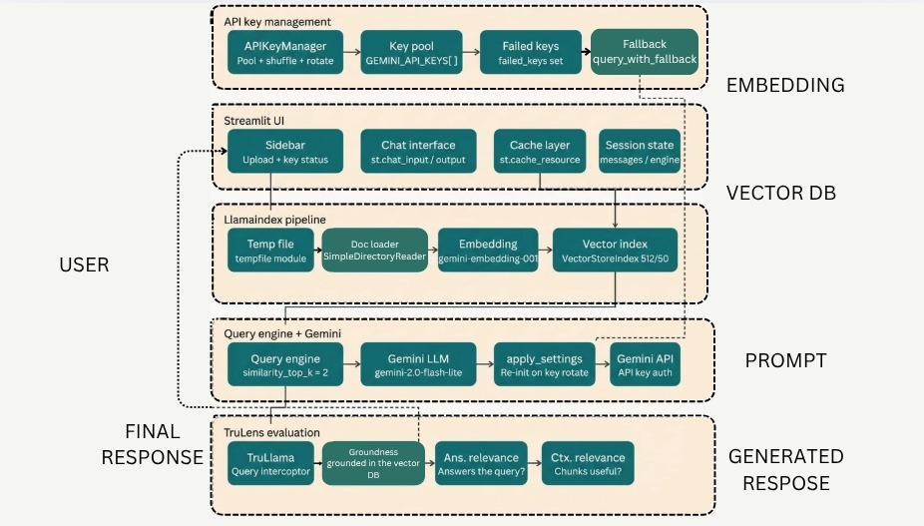

6.2 System Architecture
The system architecture consists of 5 layers. The system architecture ensures that collected data transitions securely and meaningfully from raw PDF content to verified, context-grounded responses. It will be explained layer by layer as this is how the program is divided.
Layer 1 — API key management: The APIKeyManager class shuffles the key pool on startup, tracks failed keys in a set, and query_with_fallback automatically rotates and re-initialises whenever a quota error hits which is responsible for ensuring uninterrupted access to the Gemini API across extended usage sessions without any manual intervention from the user.
Layer 2 — Streamlit UI: The sidebar handles the PDF upload and the sidebar provides real-time visibility into which keys are active, on standby, or exhausted, giving the user operational awareness during extended sessions. Session state persists the messages list and query engine across reruns, and st.cache_resource prevents the index from rebuilding unnecessarily.Layer 3 — LlamaIndex pipeline: PDF bytes go into a temp file using Python's tempfile module since LlamaIndex's SimpleDirectoryReader requires a file path rather than raw bytes, SimpleDirectoryReader loads it, GeminiEmbedding converts it into vectors with chunk size 512 and overlap 50, and the resulting embeddings are stored in a VectorStoreIndex, which serves as the system's in-memory knowledge base for the duration of the session.
Layer 4 — Query engine + Gemini: The Query Engine and Gemini layer handles runtime question answering. It retrieves the top 2 chunks (meaning the two most semantically relevant document chunks) and passes them to the Gemini LLM (gemini-2.0-flash-lite). The apply_settings is the key glue — it re-initialises both Settings.llm and Settings.embed_model every time the key rotates.
Layer 5 — TruLens evaluation: TruLlama wraps the query engine and intercepts every call to run three feedback checks — Groundedness, which verifies whether the generated answer is supported by the retrieved vector DB context rather than hallucinated; Answer Relevance, which checks whether the response directly addresses the user's question; and Context Relevance, which evaluates whether the retrieved document chunks were meaningfully useful for the query — and scores come back to the UI as colour-coded results — green for high quality, orange for moderate, and red for poor — giving the user immediate feedback on response reliability.
At its core, the design emphasizes four main components: GUI(Graphical User Interface), vector embedding, answer generation and authentification. It is designed in such a way that the user is required to upload a PDF in order to start or use the chatbot to make sure that it is a product strickly designed to answer queries and solely from the material that the user uploads. The answer generated with the help of Trulens which verifies the generated content by reviewing the answer with the vector database that was created through llama indexing after the PDF was uploaded.
Error handling is deeply integrated throughout the system design. Every API quota failure is caught within query_with_fallback, logged with a warning, and automatically resolved through key rotation. The asynchronous-style structure of Streamlit ensures that such errors do not disrupt the conversational flow.
Thus, the design of Med-Buddy seamlessly integrates PDF document indexing, vector-based retrieval, LLM-powered generation, cryptographic-style API key rotation, and automated response evaluation into one unified and extensible conversational intelligence framework.

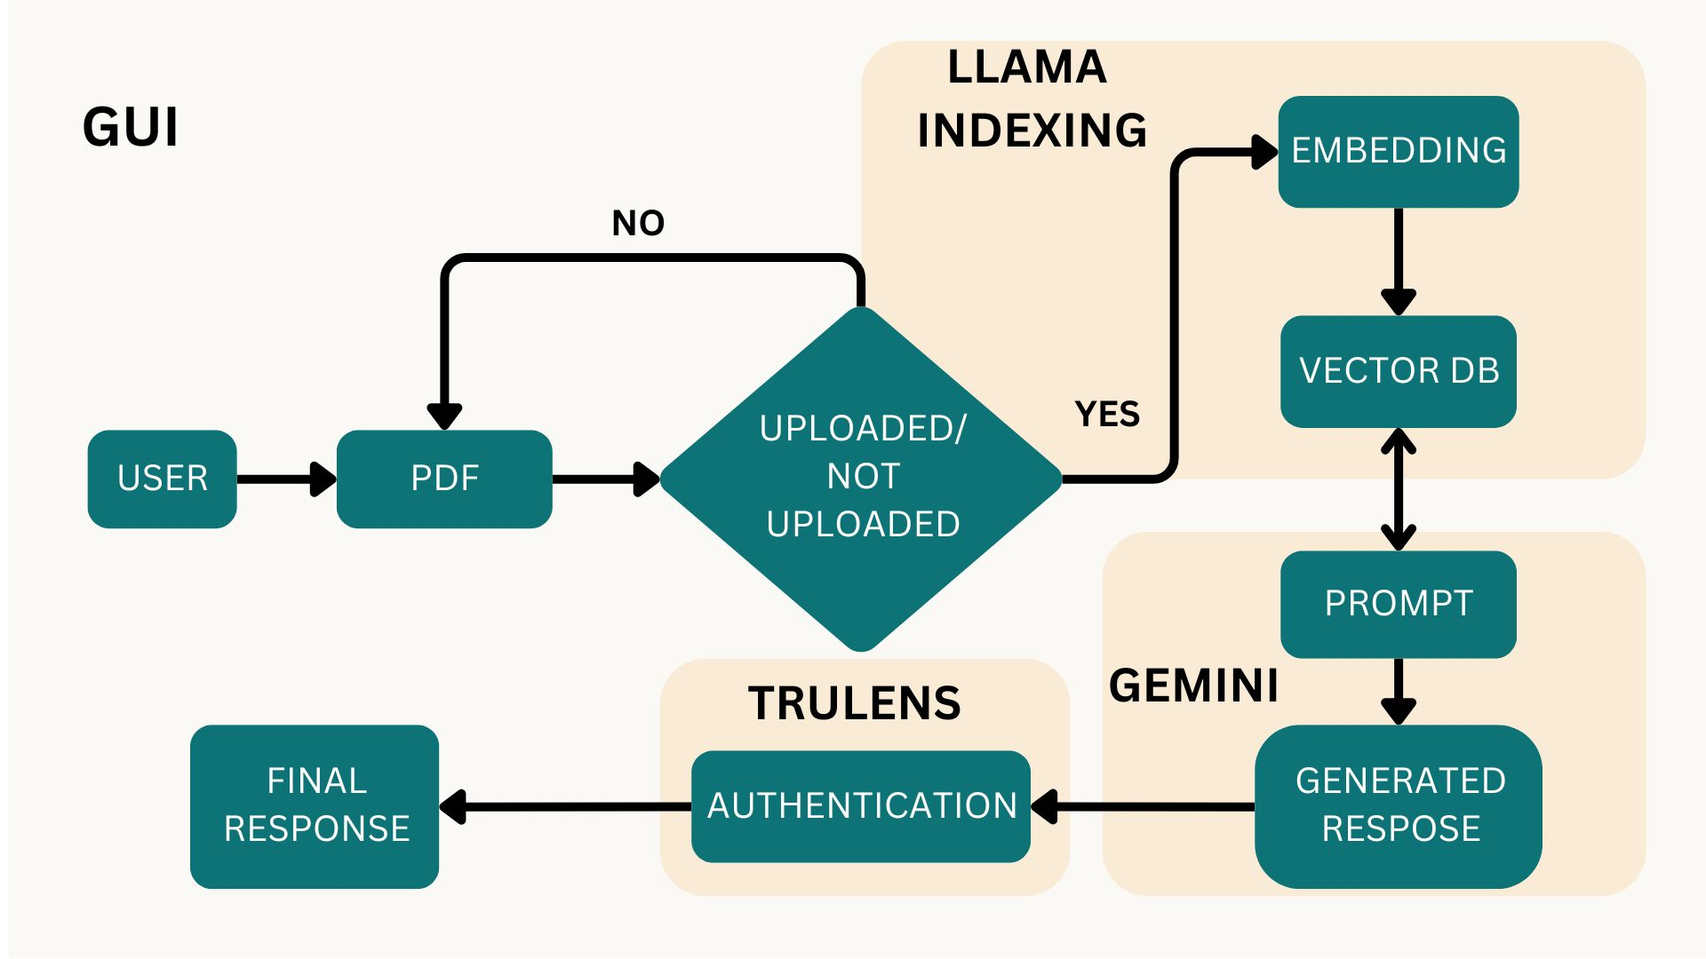
6.3 Our Contribution
The design of the Med-Buddy we have created is an advanced version of the model mentioned in the base paper. The system architecture is designed as a layered structure that integrates user interaction, data processing, intelligent querying, and evaluation into a cohesive pipeline.
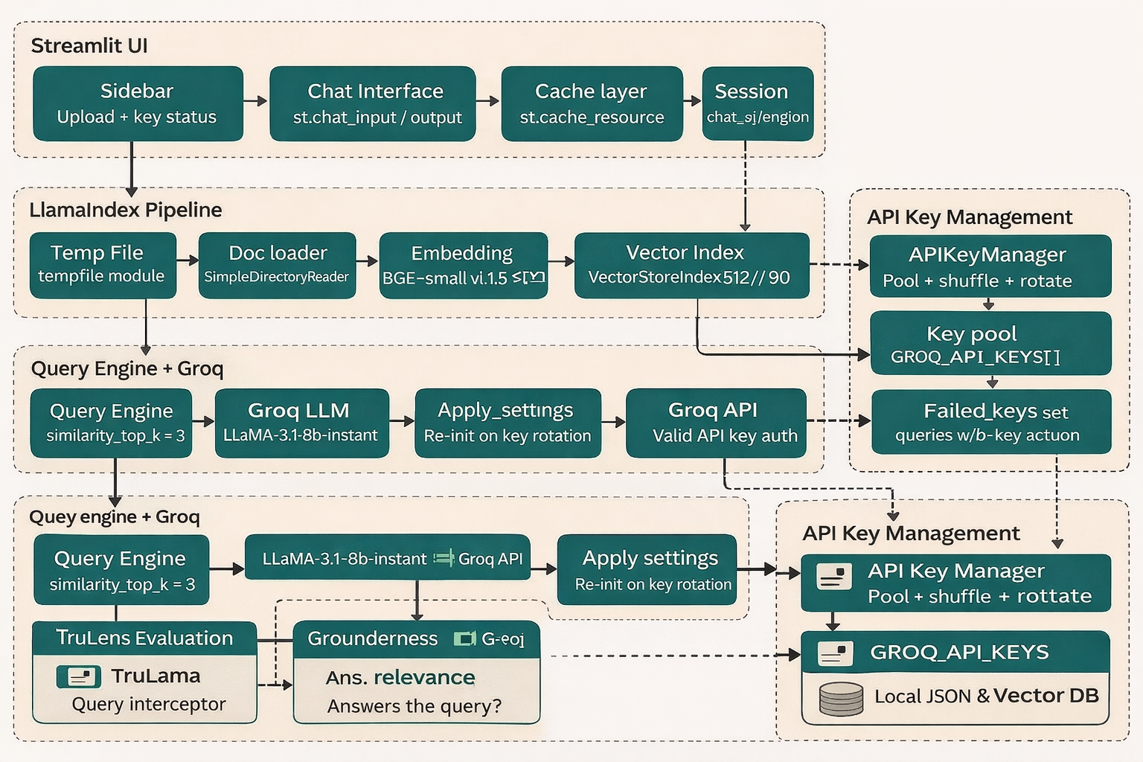
6.4 System Architecture
At the top layer is the Streamlit-based user interface, which serves as the primary interaction point for users. This layer includes components such as the sidebar for uploading PDF files and managing API keys, and a chat interface that allows users to input queries and receive responses. The interface also maintains session state, which stores chat history, the currently loaded document, and query-related objects to ensure continuity across interactions. Additionally, a caching mechanism is used at this level to store reusable resources such as models and responses, reducing redundant computations.
Beneath the interface lies the data processing layer, implemented using LlamaIndex. This layer is responsible for transforming unstructured PDF data into a structured and searchable format. When a PDF is uploaded, it is temporarily stored and then processed using a document reader that extracts textual content. The extracted text is segmented into smaller chunks using a sentence-splitting mechanism, ensuring that each piece of information is manageable and meaningful. These chunks are then passed through a local embedding model, which converts them into vector representations. These vectors are stored in a vector index, enabling efficient similarity-based retrieval during query processing. The system also incorporates persistent storage, where indexed data is saved locally using a hash-based directory structure, allowing the system to reload previously processed documents without repeating the entire indexing process.
The query processing layer is built around a query engine that integrates the vector index with a large language model provided by Groq. When a user submits a query, the system retrieves the most relevant chunks from the vector database based on similarity measures. These chunks serve as contextual input to the language model, which generates a coherent and context-aware response. A key feature of this layer is the API key management system, which maintains a pool of API keys and implements a rotation mechanism to handle rate limits or quota exhaustion. If a request fails due to limitations, the system automatically switches to another available key and retries the operation, ensuring robustness and uninterrupted service.
Another important component of the architecture is the evaluation layer, which uses TruLens to assess the quality of generated responses. This layer wraps around the query engine and evaluates outputs based on metrics such as groundedness, answer relevance, and context relevance. These evaluations help ensure that the responses are accurate, meaningful, and well-supported by the source data. The results of these evaluations can also be displayed to the user, providing transparency into the system’s performance.

6.5 Flow Chart
The flowchart represents the complete journey of data in the system, starting from the user input and ending with the final response. Initially, the user uploads a PDF file through the interface. The system then checks whether the uploaded PDF has already been processed earlier by generating a unique hash value using an MD5 algorithm. This hash helps in identifying duplicate files and enables efficient reuse of previously computed data.
If the PDF has already been indexed, the system directly loads the stored index from the cache, avoiding redundant computation. If it is a new file, the system proceeds to process it by extracting the text content using a PDF reader and then dividing the content into smaller chunks. These chunks are converted into numerical vector representations using a local embedding model, and the resulting vectors are stored in a vector database for efficient retrieval.
Once the indexing process is complete, the system waits for the user to input a query. When a query is entered, the system first checks whether the same query has been asked before. If a cached response exists, it is returned immediately to improve performance. Otherwise, the system retrieves the most relevant chunks from the vector database and sends them along with the query to the language model for answer generation.
The generated response is then evaluated using a feedback mechanism to measure its relevance and correctness. Finally, the validated response is displayed to the user and stored in the cache for future reuse. Thus, the flowchart illustrates a smooth and optimized pipeline from data input to intelligent outputThus the system operates as a well-structured pipeline where each stage contributes to transforming raw input into meaningful output. The flowchart captures this process by illustrating how a user-provided PDF is analyzed, indexed, and queried to generate accurate responses. Meanwhile, the system architecture provides the underlying framework that enables this flow, integrating multiple components such as data processing, retrieval mechanisms, language models, caching, and evaluation tools. Together, they ensurethat the system is not only functional but also efficient, reliable, and capable of delivering high-quality results in real time.
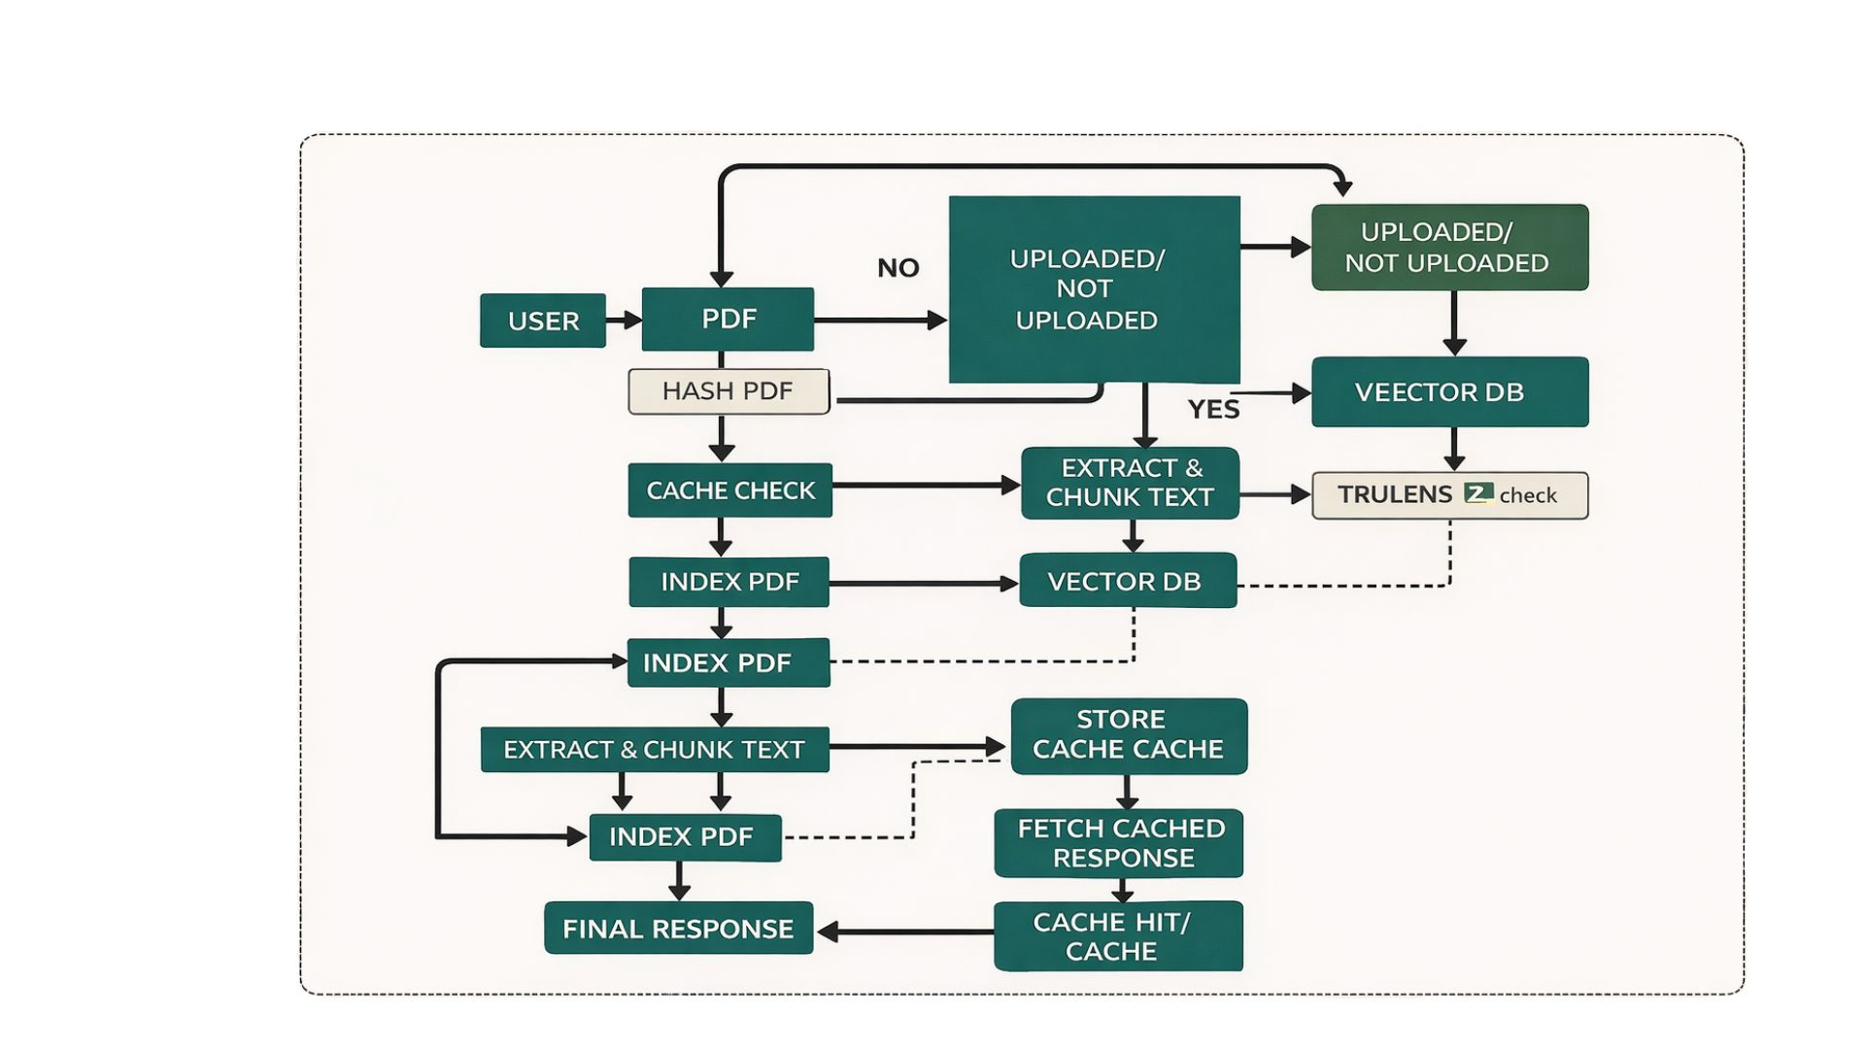

6.6 Implementation
The implementation of Med-Buddy represents an evolution from a fully API-dependent architecture to a hybrid system that combines local computation with external language model inference, thereby improving reliability, efficiency, and scalability. While the earlier version of the system relied entirely on Gemini APIs for both embedding generation and response synthesis, practical limitations such as API quota exhaustion, latency, and instability in embedding generation necessitated a redesign. The updated implementation addresses these issues by offloading embedding computation to a local model while retaining a robust and high-performance language model through Groq, resulting in a more fault-tolerant and cost-efficient conversational system.
At the core of this improved system lies the API key management mechanism, which has been retained and adapted for use with Groq APIs. The APIKeyManager class maintains a pool of API keys, which are deduplicated and shuffled to ensure balanced usage. An index pointer tracks the currently active key, while a failed_keys set records keys that have exceeded their quota or encountered errors. The rotate method iterates through the key pool using modular arithmetic, selecting the next available non-failed key. The mark_failed method flags a key as unusable and immediately triggers rotation, while the all_failed method detects complete exhaustion of the key pool and prevents infinite retries. This mechanism ensures uninterrupted access to the Groq language model, significantly improving system robustness compared to the earlier Gemini-based implementation.
A major architectural improvement is the introduction of a local embedding pipeline using FastEmbed. In contrast to the previous approach, where embeddings were generated through the Gemini embedding API, the new system defines a custom LocalFastEmbed class that extends the BaseEmbedding interface from LlamaIndex. This wrapper utilises the fastembed library to generate embeddings locally using the BAAI/bge-small-en-v1.5 model. By executing embedding operations offline, the system eliminates dependency on external APIs for vector generation, thereby reducing latency, avoiding quota limitations, and significantly lowering operational costs. This change is particularly impactful because embedding is the most frequently invoked operation during indexing, and moving it locally removes a major bottleneck in the system.
The apply_settings function has been updated to reflect this hybrid configuration. Instead of assigning both the language model and embedding model to API-based services, it now sets the embedding model to the LocalFastEmbed instance while configuring the language model as a Groq-based LLaMA 3.1 model. Additionally, chunking parameters have been adjusted to a size of 1024 tokens with an overlap of 90 tokens, enabling better context preservation during retrieval. This function is invoked during system initialisation and after every API key rotation to ensure consistent configuration across all components.
The document ingestion and indexing pipeline has also been significantly enhanced. The build_index function implements a persistent and fault-tolerant indexing mechanism that uses an MD5 hash of the PDF file to uniquely identify documents. This hash is used to create a dedicated storage directory, allowing previously indexed documents to be reloaded instantly without recomputation. If a cached index exists and is marked as complete, it is loaded directly from disk using LlamaIndex’s storage context. Otherwise, the system processes the PDF by extracting text using PyMuPDFReader, with a fallback to SimpleDirectoryReader in case of failure. The extracted content is then split into chunks using SentenceSplitter, embedded locally, and inserted into a VectorStoreIndex in batches. A checkpointing mechanism records progress after each batch, enabling the indexing process to resume seamlessly in caseb of interruptions. This persistent caching strategy represents a major improvement over the earlier implementation, where indexing was recomputed for each session.
The query processing layer is implemented through the query_with_fallback function, which integrates response caching, key rotation, and TruLens evaluation into a unified execution pipeline. Before executing a query, the system checks whether an identical prompt has already been processed and stored in the response cache. If so, the cached response is returned instantly, reducing redundant computation and API usage. If not, the query is passed to the LlamaIndex query engine, which retrieves the most relevant document chunks and forwards them to the Groq LLaMA model for response generation. The entire process is wrapped in a retry loop that handles quota-related exceptions. Upon encountering such errors, the system automatically rotates the API key, reinitialises the query engine, and retries the query without user intervention. This ensures a seamless user experience even under heavy usage conditions.
The evaluation layer, implemented using TruLens, remains a critical component of the system. The get_feedback_functions function constructs multiple feedback evaluators using a LiteLLM provider configured for Groq. These evaluators measure groundedness, answer relevance, and context relevance by analysing the relationship between the query, retrieved context, and generated response. Each query execution is recorded through a TruLlama wrapper, enabling post-hoc analysis of response quality. The results are displayed within the user interface, providing transparency and allowing users to assess the reliability of the system’s outputs. Compared to the earlier implementation, this evaluation mechanism now operates more efficiently due to reduced API contention.
The Streamlit-based user interface orchestrates all system components and provides a seamless interaction experience. The sidebar enables users to upload PDF files, manage API keys, monitor evaluation metrics, and perform cache operations. Uploaded files trigger the indexing pipeline only when a new document is detected, preventing unnecessary recomputation. The main chat interface maintains conversation history using session state, displays user queries and system responses, and integrates evaluation metrics within expandable sections. Additional controls allow users to clear chat history, reset the system state, and manage cached indices, enhancing usability and control.
Overall, the updated implementation of Med-Buddy transforms the system into a hybrid retrieval-augmented architecture that balances local computation with external intelligence services. By replacing Gemini-based embeddings with FastEmbed, the system eliminates a major source of unreliability and reduces API dependency. The adoption of Groq for language model inference further enhances performance and stability. Combined with persistent indexing, response caching, and robust API key rotation, the system achieves a high degree of efficiency, scalability, and fault tolerance. This improved implementation not only addresses the limitations of the previous design but also establishes a more sustainable and production-ready framework for document-based conversational intelligence.
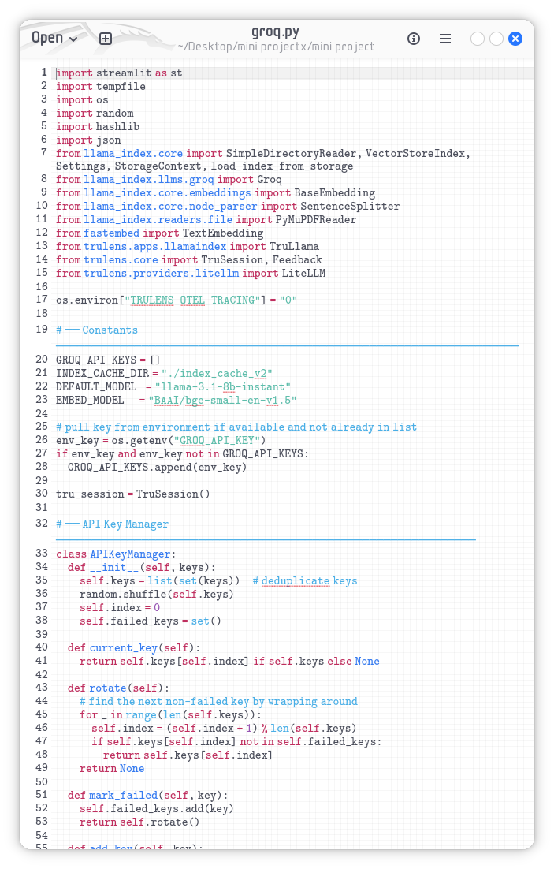

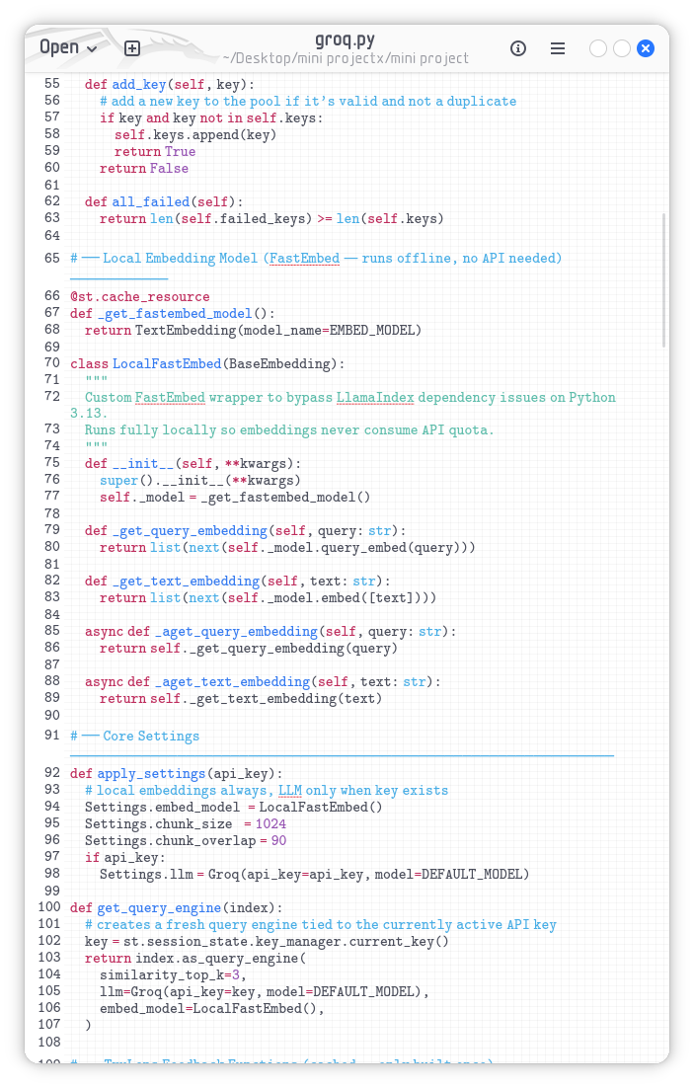
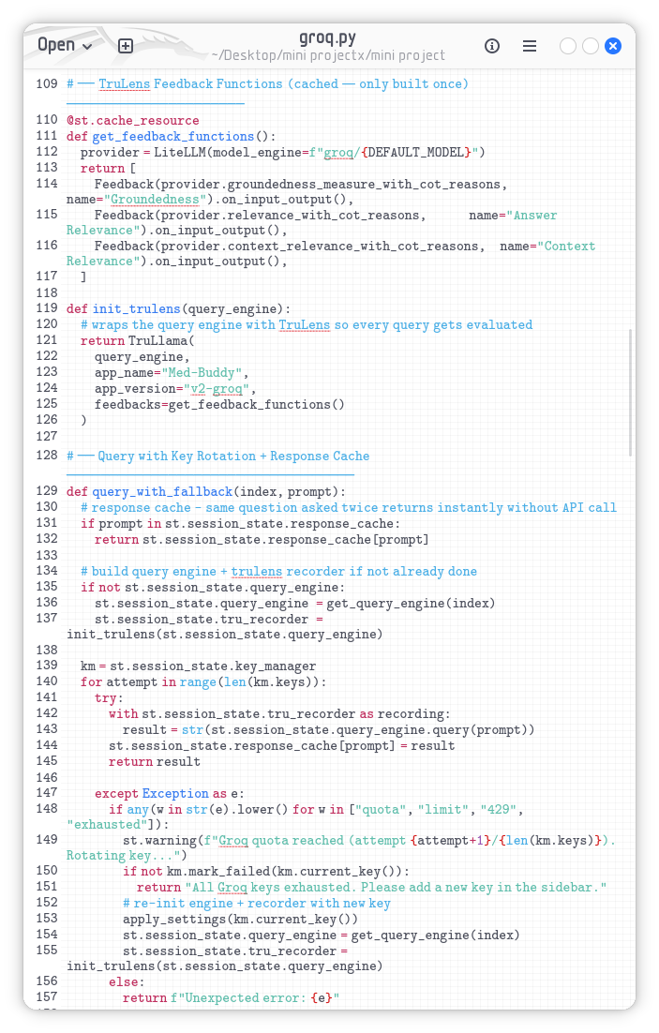
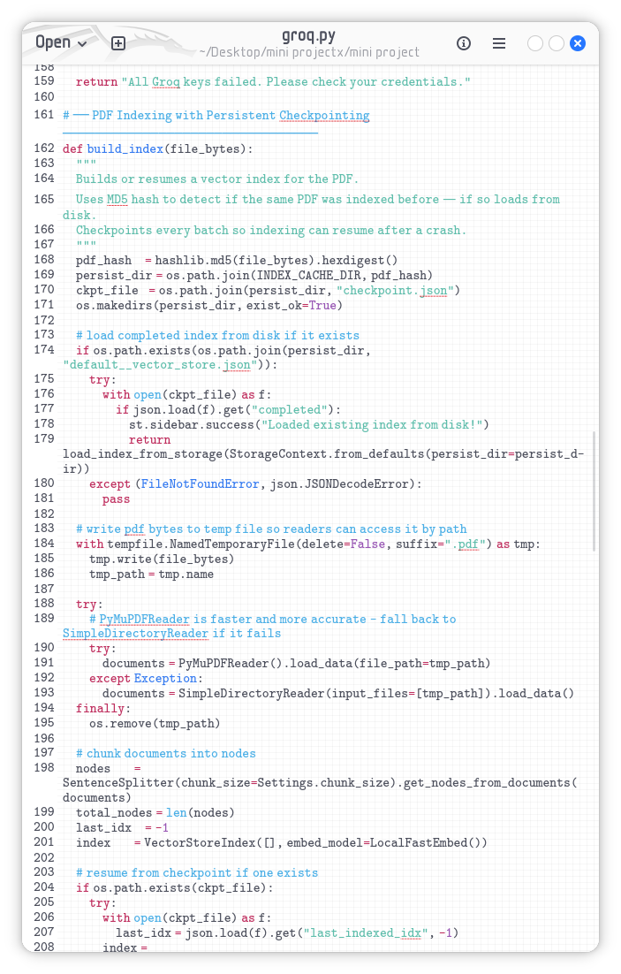
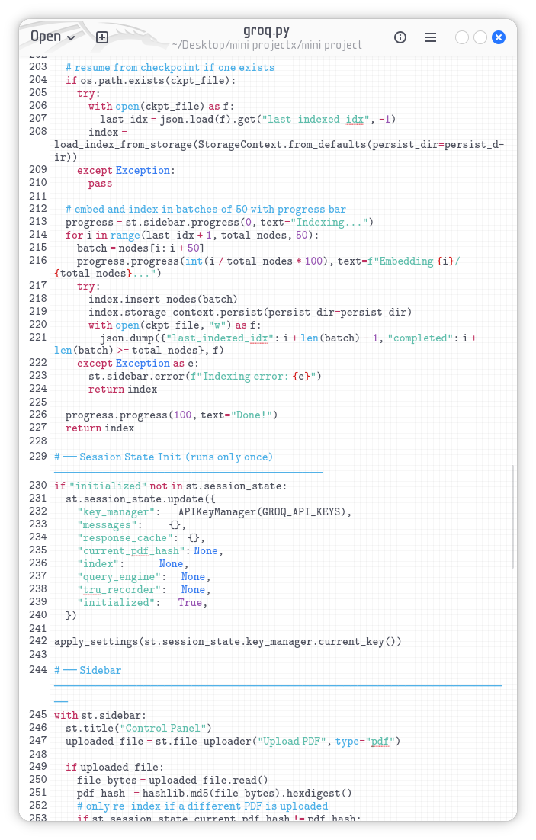
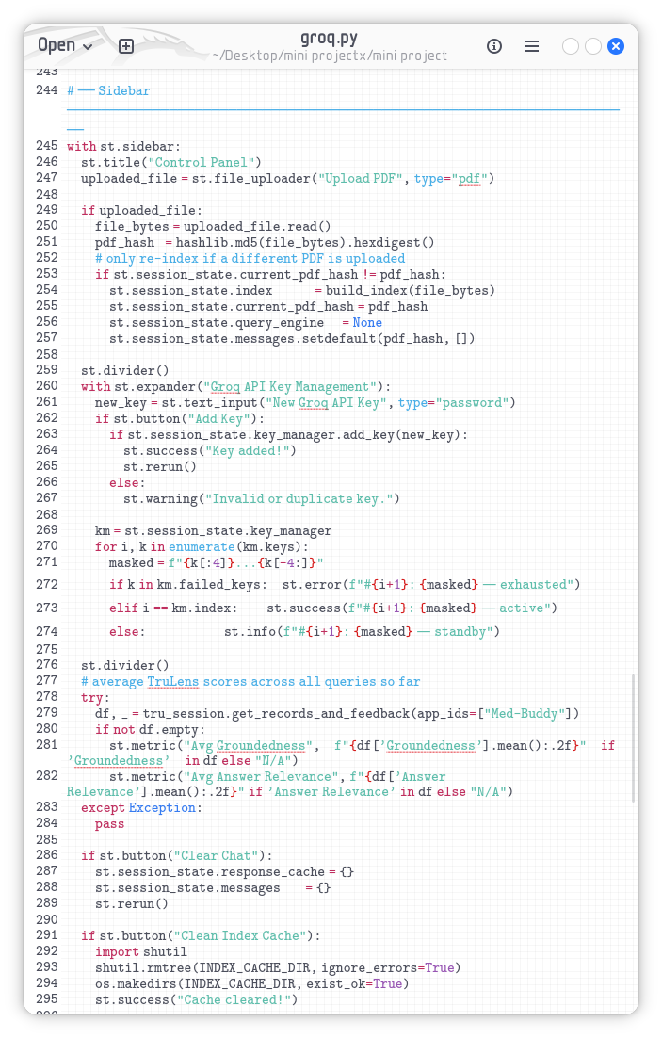
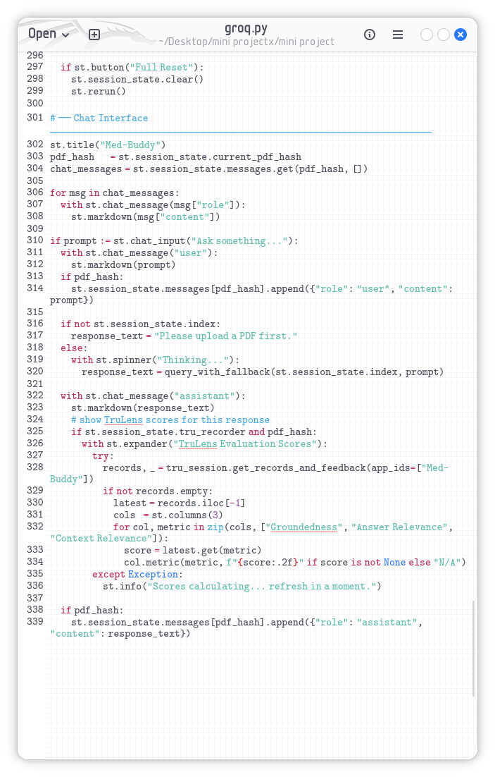
CHAPTER 7

7.RESULT
7.1 Graphical User Interface (Home Page)
The MedBuddy application features a sophisticated, modern, and highly intuitive web-based interface built upon the Streamlit framework. Recognizing that healthcare professionals require streamlined, distraction-free tools, the UI is designed with a minimalist medical aesthetic. The main dashboard provides an immediate overview of the system's capabilities, ensuring that users can begin interacting with the application with zero learning curve.
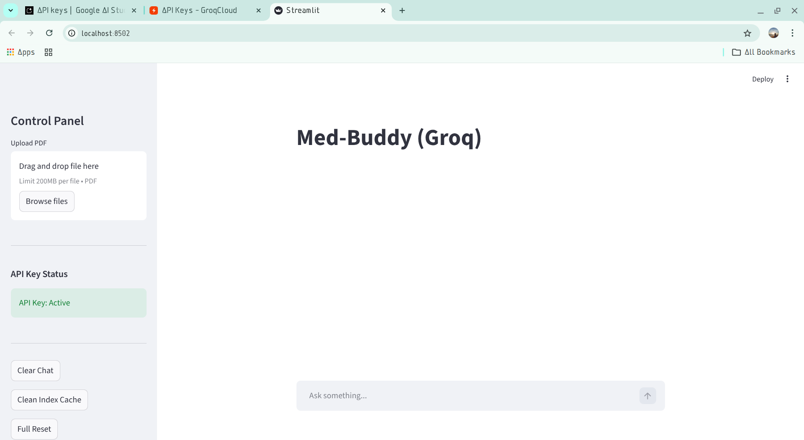
7.2 Document Management and Ingestion Interface
The application features a dedicated, collapsible sidebar strictly allocated for document management. Users are presented with a drag-and-drop file uploader that accepts multiple PDF documents simultaneously. Once documents are uploaded and the user initiates the processing phase, the interface provides dynamic visual feedback. A progress spinner indicates that the local Hugging Face embedding process has commenced. Because our contribution localized this process, the user experiences incredibly fast processing times, watching the system ingest, chunk, and vectorize hundreds of pages in mere seconds, culminating in a "Processing Complete" success message.

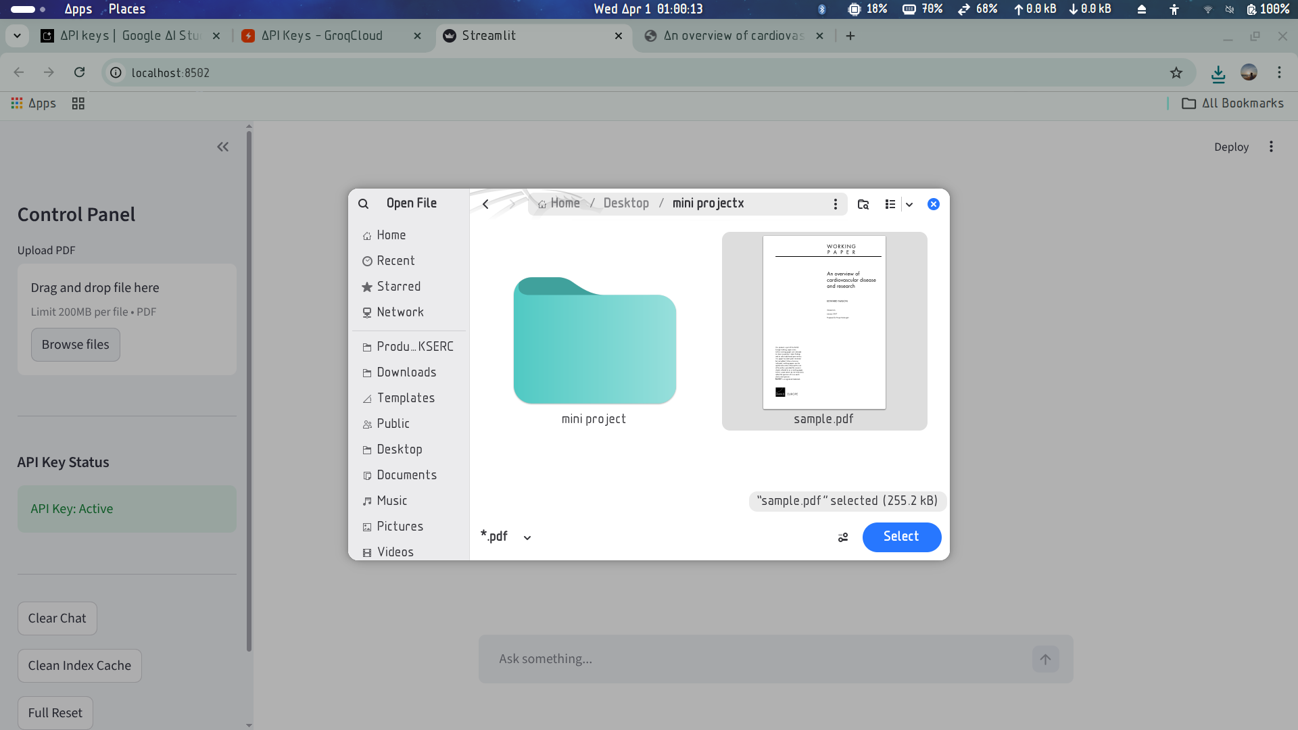
7.3 Query Interface & Result Generation
The central portion of the application is dedicated to the conversational interface. A prominent text input box allows users to type complex medical questions. Upon submission, the system rapidly queries the local vector database and contacts the LLM.
The generated results are displayed in a clean, chat-bubble format. Crucially, the results validate the success of our RAG implementation: the answers generated are highly specific, clinically accurate, and directly address the user's query based only on the uploaded texts. To ensure complete transparency, the interface can be configured to display "Source Citations"—a dropdown that reveals the exact text chunks that the Hugging Face model retrieved from the PDFs. This allows the medical professional to cross-reference the AI's answer with the source material instantaneously, building trust in the system's outputs.
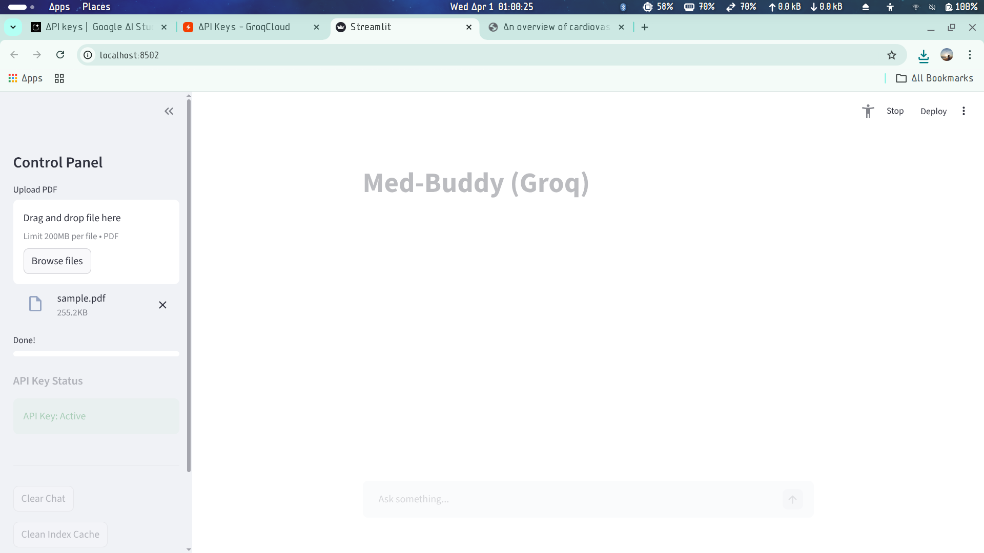
7.4 Performance Comparison (Base vs. Contributed System)
The results of implementing our Hugging Face contribution yielded massive performance upgrades over the base paper's methodology.
- Ingestion Speed: The local Hugging Face model processed large medical PDFs significantly faster than the base system, as it did not have to wait for HTTP request round-trips to Google's servers.
- Cost Reduction: API token usage during the document upload phase was reduced to absolute zero.
- Accuracy: The retrieval accuracy of the local all-MiniLM-L6-v2 model proved to be highly robust, fetching the correct medical context with precision comparable to the paid enterprise APIs, confirming that the hybrid approach is highly successful.
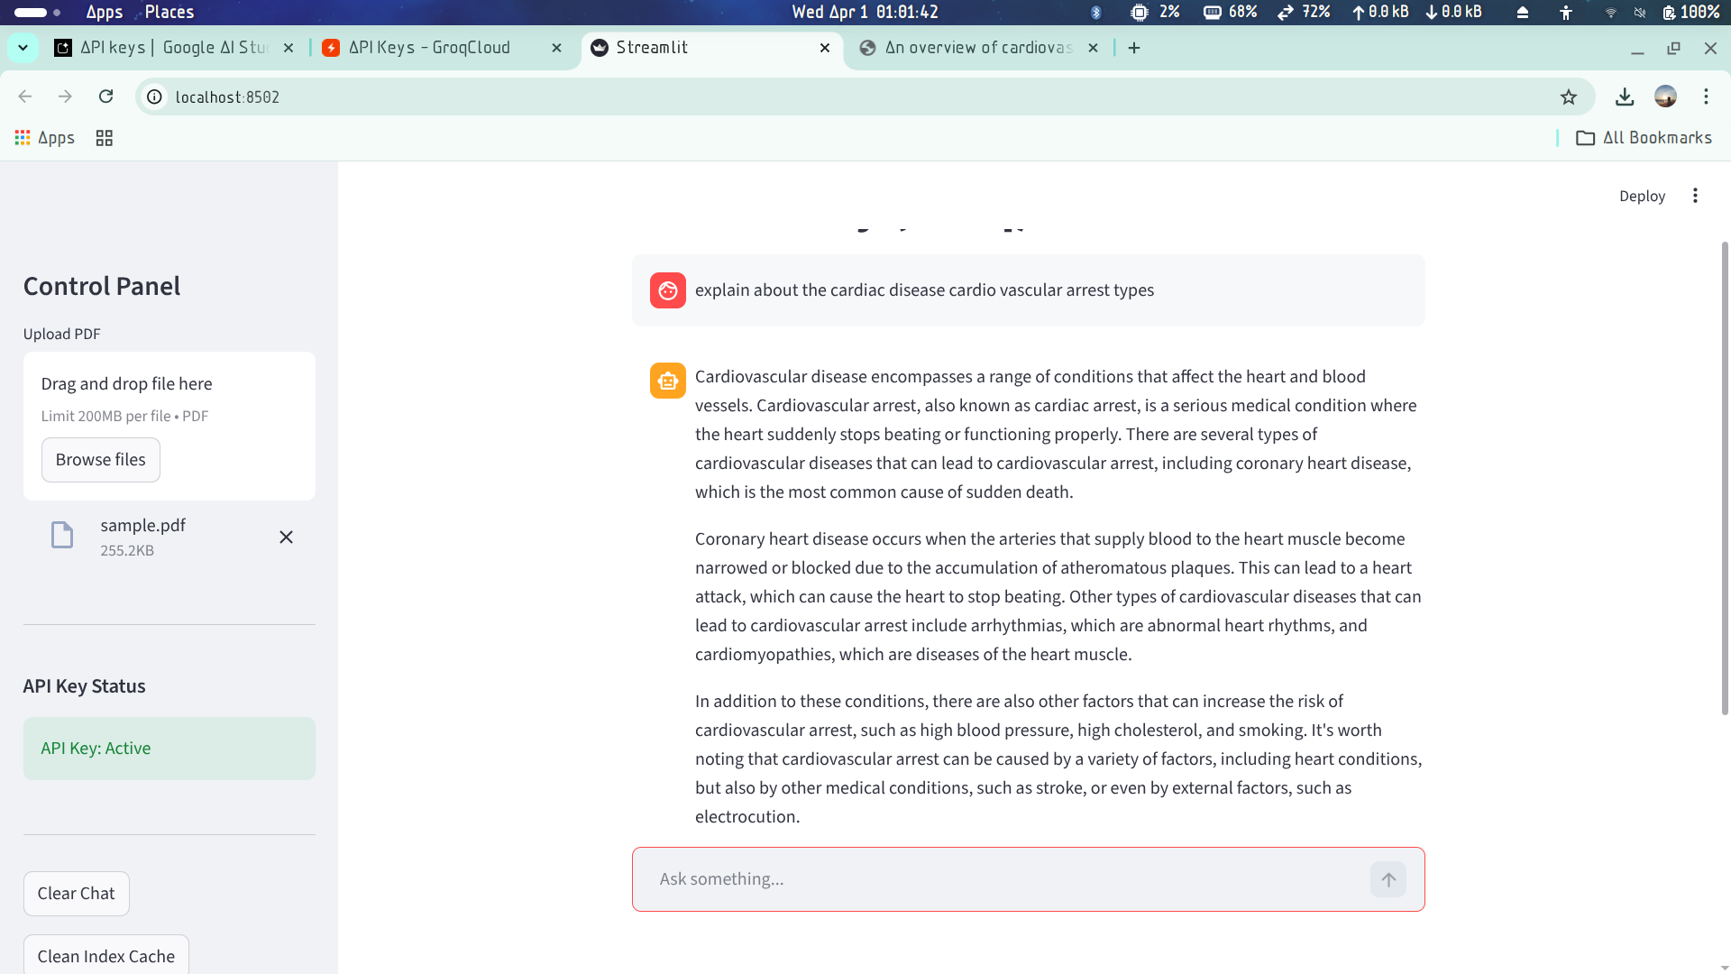
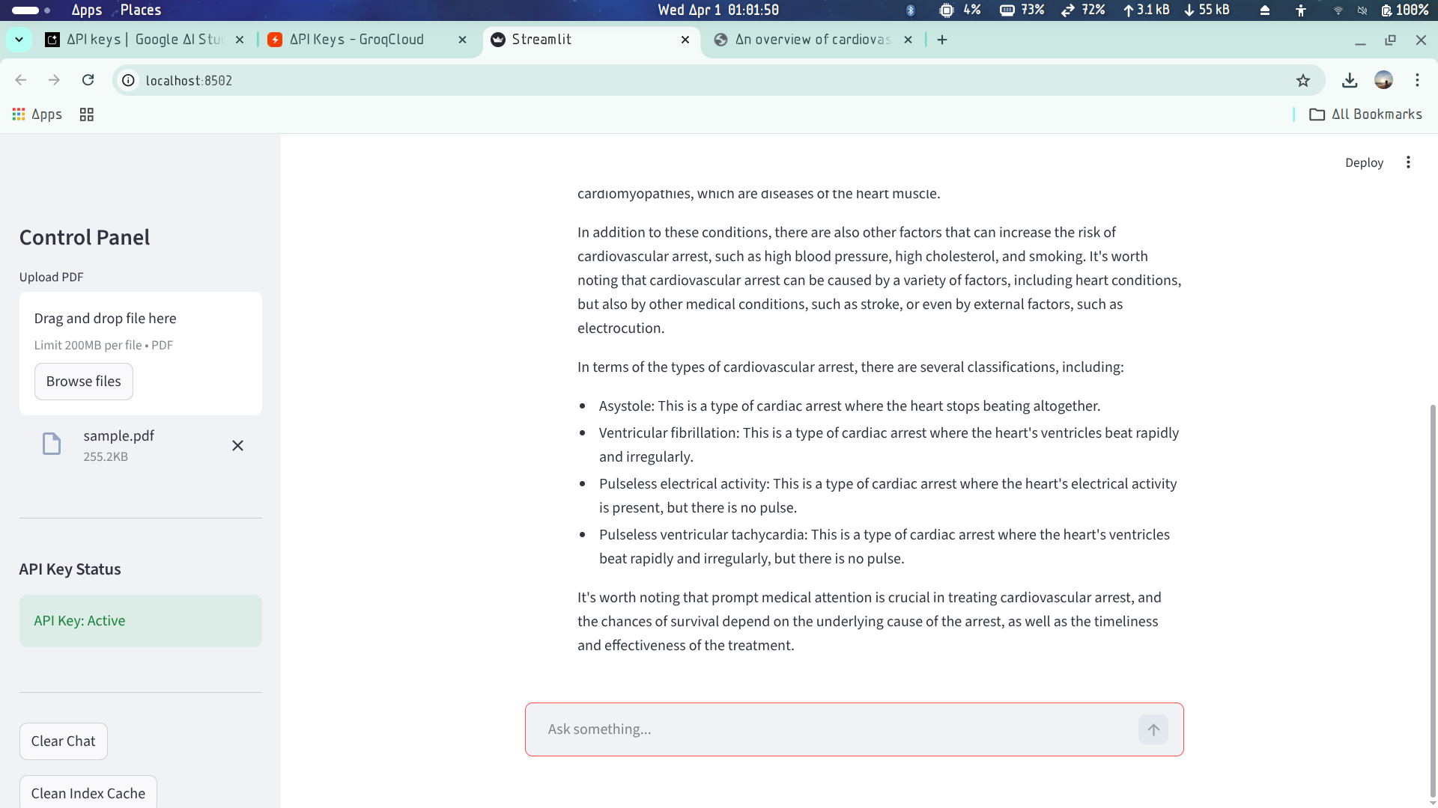
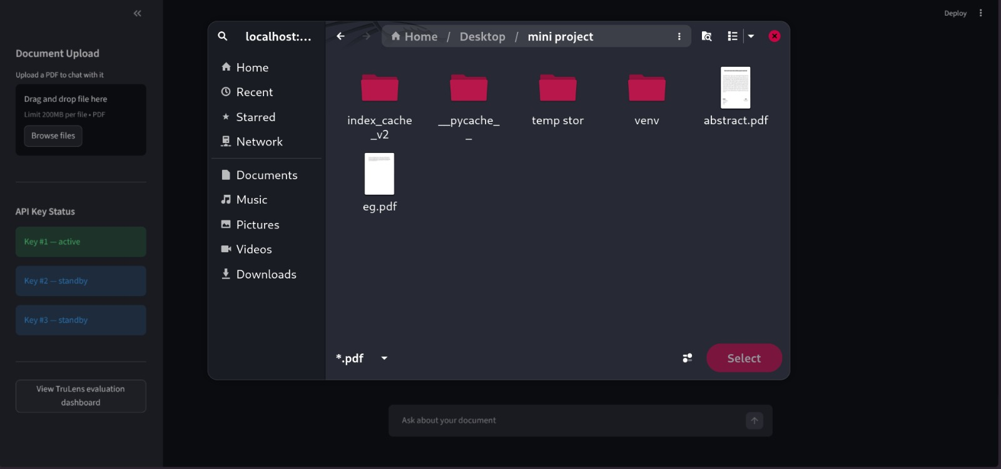
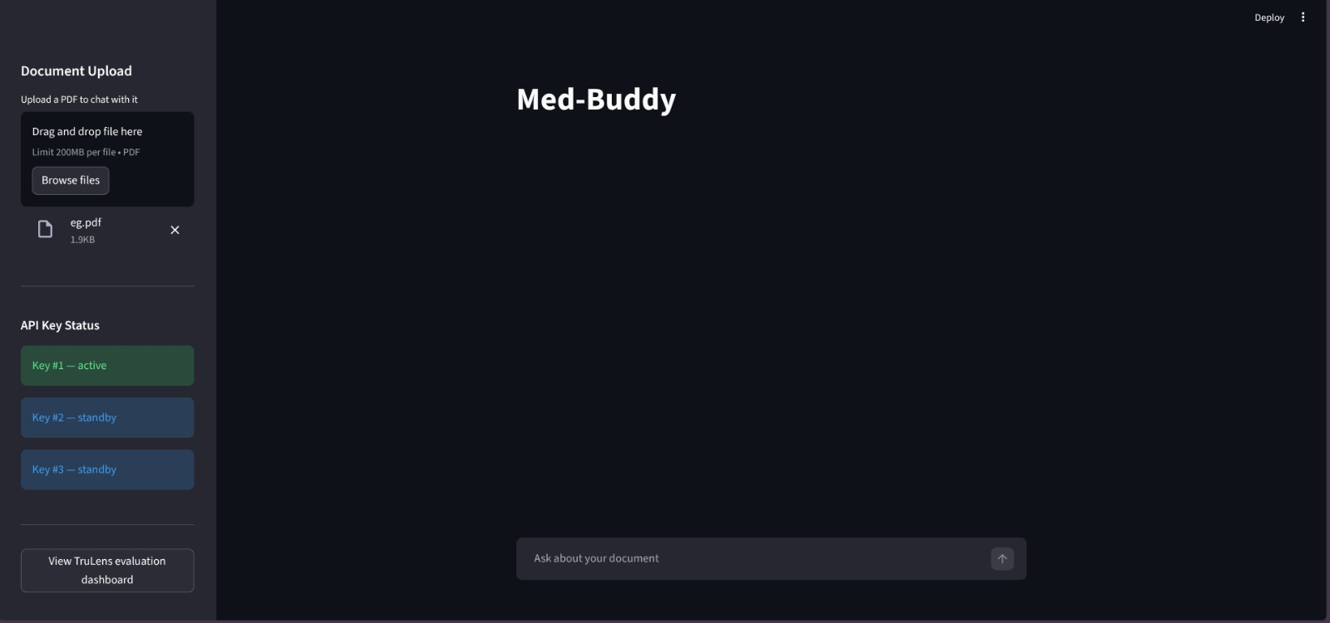
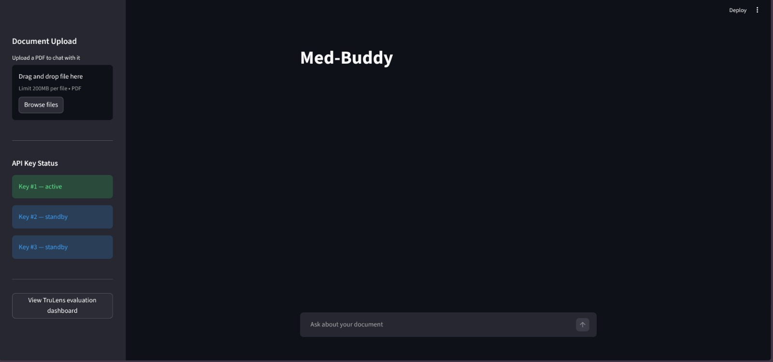
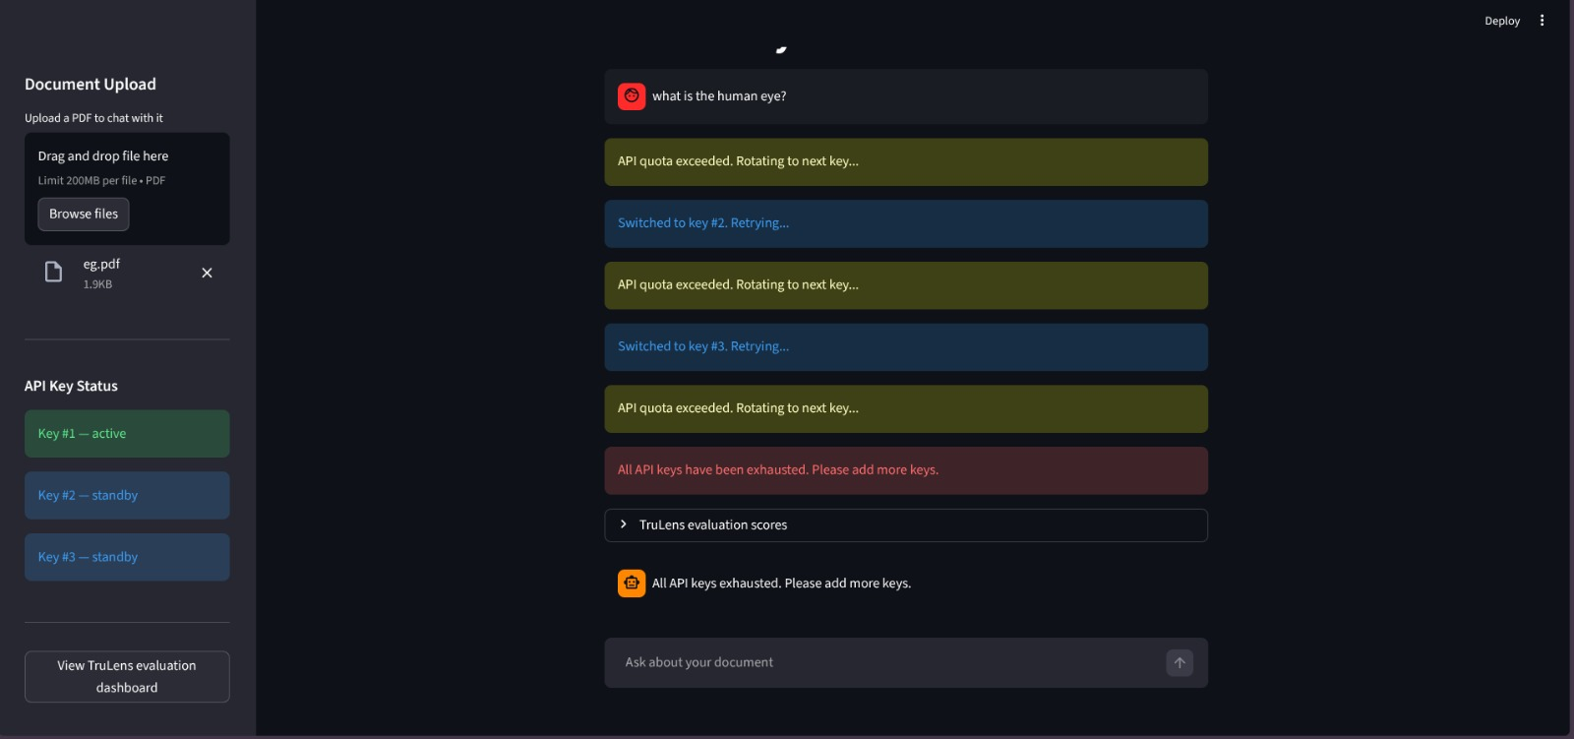

CHAPTER 8

8.CONCLUSION AND FUTURE SCOPE
8.1 Conclusion
The development and deployment of the MedBuddy project successfully demonstrate the profound efficacy of domain-specific, localized Retrieval-Augmented Generation (RAG) frameworks. By critically analyzing the base Gemini-driven architecture and subsequently engineering a robust enhancement—specifically, the integration of local Hugging Face transformers for vector embedding—we achieved an optimal balance between high-level AI intelligence and stringent data security.
The finalized MedBuddy system drastically mitigates the risks associated with cloud-based AI in healthcare. It eliminates the danger of exposing sensitive medical documents to external servers during the ingestion phase, drastically reduces operational costs by cutting token usage, and maintains an exceptionally high standard of factual accuracy. By strictly grounding the LLM's generative capabilities in the secure, locally retrieved medical texts, MedBuddy proves to be a powerful, viable, and safe tool for medical professionals to rapidly access critical clinical knowledge.
8.2 Future Scope
While the current MedBuddy framework represents a significant leap forward by localizing the embedding process, the final text generation phase still relies on an external API connection to Gemini. The ultimate future scope for this project involves transitioning the architecture to a 100% offline, fully air-gapped system.
This can be achieved by completely removing the Gemini dependency and replacing it with local, open-source generative models such as Meta's Llama-3 or Mistral-7B. By utilizing advanced model quantization techniques (such as GGUF formats running on frameworks like llama.cpp), these heavy generative models could be executed efficiently on standard hospital hardware without the need for multi-million dollar enterprise GPU clusters.
Furthermore, future iterations of MedBuddy could be expanded to include Multi-Modal RAG, allowing the system to ingest and analyze medical imagery (X-rays, MRIs) alongside text. Finally, deep integration with existing Electronic Health Record (EHR) systems utilizing HL7 or FHIR standards would allow MedBuddy to automatically cross-reference a patient's real-time chart against the uploaded medical guidelines, providing hyper-personalized, secure clinical decision support.

REFERENCES

- Oh, N., Cha, W. C., Seo, J. H., et al. (2024). ChatGPT predicts in-hospital all-cause mortality for sepsis: in-context learning with the Korean Sepsis Alliance Database. Healthcare Informatics Research, 30(3), 266-276.
- Jovanovic, M., Baez, M., & Casati, F. (2020). Chatbots as conversational healthcare services. IEEE Internet Computing, 25(3), 44-51.
- Sun, G., & Zhou, Y. H. (2023). AI in healthcare: navigating opportunities and challenges in digital communication. Frontiers in Digital Health, 5, 1291132.
- Xu, L., Sanders, L., Li, K., & Chow, J. C. L. (2021). Chatbot for health care and oncology applications using artificial intelligence and machine learning: systematic review. JMIR Cancer, 7(4), e27850.
- Habicht, J., Viswanathan, S., Carrington, B., et al. (2024). Closing the accessibility gap to mental health treatment with a personalized self-referral chatbot. Nature Medicine, 30(2), 595-602.
- Zhou, Q., Liu, C., Duan, Y., et al. (2024). GastroBot: a Chinese gastrointestinal disease chatbot based on retrieval-augmented generation. Frontiers in Medicine, 11, 1392555.
- Ranasinghe, S., De Silva, D., Mills, N., et al. (2024). Addressing the productivity paradox in healthcare with retrieval augmented generative AI chatbots. Proceedings of 2024 IEEE International Conference on Industrial Technology.
- Bora, A., & Cuayahuitl, H. (2024). Systematic analysis of retrieval-augmented generation-based LLMs for medical chatbot applications. Machine Learning and Knowledge Extraction, 6(4), 2355-2374.
- Wang, L., Yang, N., Huang, X., et al. (2024). Multilingual E5 text embeddings: A technical report. arXiv preprint arXiv:2402.05672.
- Chen, J., Xiao, S., Zhang, P., et al. (2024). BGE M3-embedding: multi-lingual, multi-functionality, multi-granularity text embeddings through self-knowledge distillation. arXiv preprint arXiv:2402.03216.
- Greene, R., Sanders, T., Weng, L., & Neelakantan, A. (2022). New and improved embedding model. OpenAI Blog. Retrieved from https://openai.com/index/new-and-improved-embedding-model/
- Google. (2024). Gemini API Documentation. Retrieved from https://ai.google.dev/docs
- LangChain. (2024). LangChain Documentation. Retrieved from https://python.langchain.com/
- TruLens. (2024). TruLens for LLMs Documentation. Retrieved from https://www.trulens.org/
- Streamlit. (2024). Streamlit Documentation. Retrieved from https://docs.streamlit.io/

